Level 1 IS Design
Version 0.1
David Lowther

Revision History
20 Jun 2026 | First Draft
24 Jun 2026 | Work in progress
28 Jun 2026 | L1 complete. Still need to do L2, but only for the Sequence Control block
30 Jun 2026 | Removed READ and WRITE
1 Jul 2026 | Finished section 4
1 Jul 2026 | Fixed a typo at the end of 4.2 “AND gate” is now “NAND gate”
2 Jul 2026 | Added INC_PC to sequence ROM output signals in 3.5  Added timing diagrams for 5 bit counter in 4.1
4 Jul 2026 | Changes to match ref 3 signals changing from active low to active high
4 Jul 2026 | Improved some of the English, no behaviour changes.  RESET should be shown as an output Figure 2 (forgot to include latest is.sch on 2 Jul) and added RESET to Table 1.

Contents
1 Introduction 1
2 Overview 1
2.1 IS Inputs and Outputs 2
2.2 IS Requirements 2
2.2.1 IS Requirements for Instruction Latch and Decode Outputs 2
2.3 IS Block Diagram 4
3 Details for Each of the Blocks Shown in Figure 2 5
3.1 Opcode Latch 5
3.2 Clock Generator 6
3.3 Power up Reset 6
3.4 Sequence Control 7
3.5 Sequence ROM 8
3.6 RAM Address Control 9
3.7 Temp 16 Bit Latch1 9
3.8 Temp 16 Bit Latch2 9
3.9 16 Bit Tristate Buffer 10
4 L2 Design for Sequence Control 11
4.1 5 Bit Counter 12
4.2 Follow Jump? 14
5 References 15

Figures
Figure 1: Relevant part of top level block diagram 1
Figure 2: IS Level 1 Block Diagram 4
Figure 3: Mapping for all outputs except JBITS 5
Figure 4: Mapping for JBITS output 5
Figure 5: Sequence ROM Layout 8
Figure 6: Sequence Control part of Figure 2 11
Figure 7: Sequence Control L2 Block Diagram 11
Figure 8: Timing requirements for 5 bit counter when RESET is high 12
Figure 9: Timing requirements for 5 bit counter when RESET is low 13

Introduction
The purpose of this document is to define how the blocks within the IS (Instruction Decode & Sequence Control) will communicate with each other, handle the signals coming into the IS, and produce the output signals from the IS.

Overview
Ref 2 defines the signals flowing in and out of the IS. The relevant part of the top level diagram from Ref 2 is shown in Figure 1.
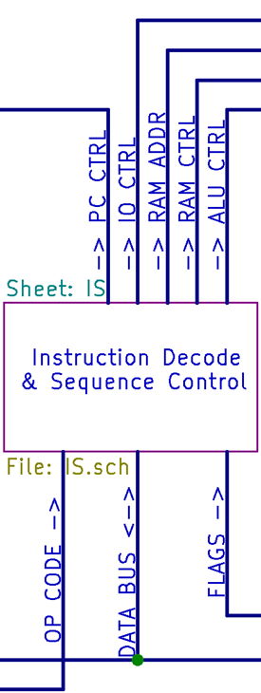
Figure 1: Relevant part of top level block diagram
The relevant section names of Ref 2, that define the signals used / provided by the IS, are:
- Overview of the Data Bus
- Common bus signals (not shown in Figure 1)
- ADDRESS bus
- OP CODE bus
- PC CTRL bus
- IO CTRL bus
- RAM CTRL bus
- RAM ADDR Bus
- ALU CTRL bus
- FLAGS bus

IS Inputs and Outputs
All the inputs to, and outputs from, the IS are listed in Table 1. Some names have been shortened for use as local names in this document.
Table 1: ALU Inputs and Outputs
Ref 2 Full Name | Local Name | Type
OPCODE BUS | OPCODE | Input
FLAGS BUS | FLAGS | Input
DATA_BUS | DBUS | Input / Output
CLOCK | CLOCK | Output
RESET | RESET | Output
SELECT_PC_DEST | SD_PC | Output
SELECT_PC_SRC | SS_PC | Output
SELECT_PNL_DEST | SD_PN | Output
SELECT_PVL_DEST | SD_PV | Output
SELECT_PNV_SRC | SS_PV | Output
SELECT_RAM_DEST | SD_RD | Output
SELECT_RAM_SRC | SS_RD | Output
ALU_MODE | MODE | Output
SELECT_ALU_DESTA | SD_AA | Output
SELECT_ALU_DESTB | SD_AB | Output
SELECT_ALUO_SRC | SS_AO | Output
RAM ADDR BUS | ABUS | Output
The main reason for shortening the names is for convenience, particularly to avoid cluttering the block diagram shown in Figure 2.

IS Requirements
Basically the IS Requirement is to perform the appropriate sequence for each opcode as defined in ref 3.

IS Requirements for Instruction Latch and Decode Outputs
These are the requirements for the Opcode Latch shown in Figure 2.
This is the done in step 0 of each sequence as shown in ref 3.
There are 17 different sequences, numbered 0 to 16. See ref 4 for full details of opcode format.
The first thing that has to be extracted from the latched opcode is the sequence number.
Depending on the sequence number, the other information that the IS needs to use from the opcode is shown in Table 2. Numbers in brackets refer to note numbers following the table.

Table 2: Information Needed for Each Sequence
 |  | Information to extract, or infer, from opcode
Seq No | Opcode | Flags | Flags Mask | Ra number | Rb number | ALU mode
0 | Jump to new address
1 | Conditional jump not followed
2 | ADD,OR,ADD,SUB,XOR Ra,Rb
3 | NOT Ra
4 | CPY Ra,Rb
5 | LIM Ra,value
6 | INC,DEC Ra |  |  |  |  | (1)
7 | POP Ra |  |  |  | (2) | (3)
8 | PUSH Ra |  |  |  | (2) | (3)
9 | CALL Ra |  |  |  | (2) | (3)
10 | RET |  |  |  | (2) | (3)
11 | STORE Ra, Address
12 | LOAD Ra, Address
13 | NOP
14 | OUT Ra,Rb
15 | IN Ra,Rb
16 | CMP Ra,Rb |  |  |  |  | (4)
Notes for Table 2:
- ALU has to do ADD or SUB Ra,1.
- IS has to use SP# (15) for PUSH, POP, CALL, and RET.
- IS has to increment or decrement SP using the ALU.
- IS has to do get ALU to do SUB Ra,Rb but not store result in Ra.

IS Block Diagram
Figure 2 shows the level 1 block diagram for the IS.
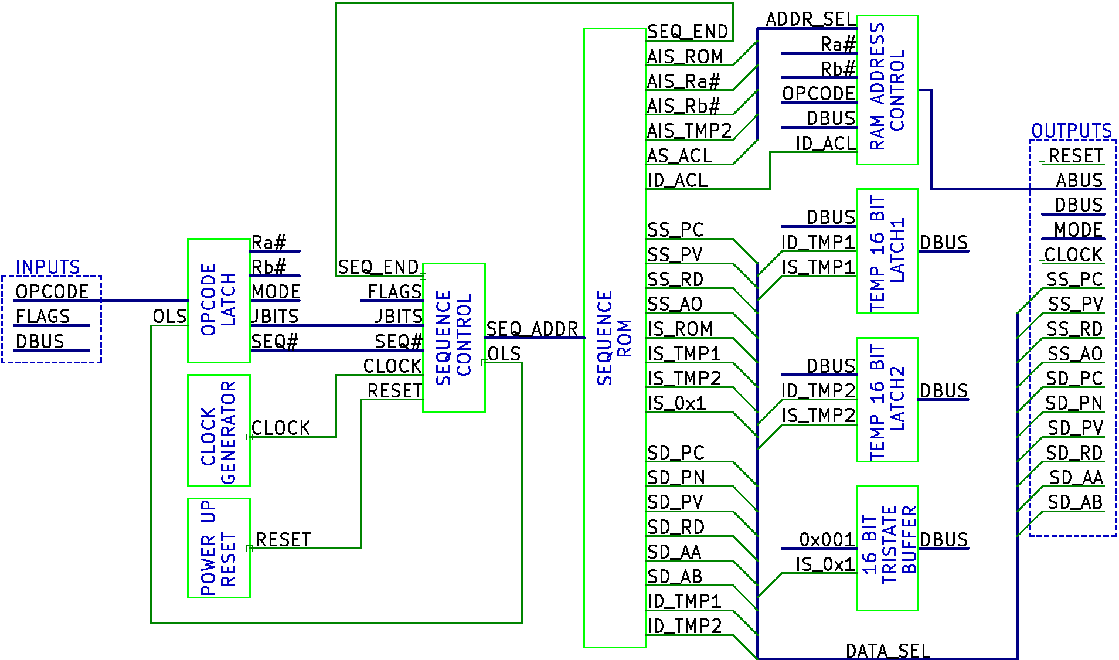
Figure 2: IS Level 1 Block Diagram

Details for Each of the Blocks Shown in Figure 2
The following sub sections, one per block shown in Figure 2, define the function of each block.

Opcode Latch
The function of this block is to:
- Store OPCODE for the first word of every instruction
- Produce the outputs shown on the right hand side of it (Ra#, Rb#, MODE, JBITS, and SEQ#).
The “OLS” (Opcode Latch Store) input will cause the opcode to be stored when OLS changes from high to low.
The outputs of this latch will be permanently enabled, i.e. it doesn’t have tri-state outputs.
The 5 output busses from this block will always be copied from the opcode as shown below (in Figure 3 and Figure 4), regardless of: the value in Seq No, the meaning of the opcode bits, and whether or not the IS needs the information to execute the sequence.
The mapping, from the opcode input, to 4 of the 5 output busses (excluding JBITS), will be as shown Figure 3:
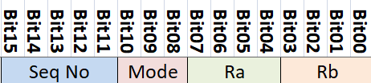
Figure 3: Mapping for all outputs except JBITS
- Rb# will consist of 4 bits numbered 3 to 0. Bit 3 of Ra# will contain Bit03 of Figure 3 etc.
- Ra# will consist of 4 bits numbered 3 to 0. Bit 3 of Rb# will contain Bit07 of Figure 3 etc.
- MODE will consist of 3 bits numbered 2 to 0. Bit 2 of MODE will contain Bit10 of Figure 3 etc.
- SEQ# will consist of 5 bits numbered 4 to 0. Bit 4 of SEQ# will contain Bit15 of Figure 3 etc.
The mapping from the opcode input to JBITS will be as shown in Figure 4.
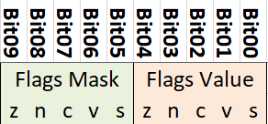
Figure 4: Mapping for JBITS output
- JBITS will consist of 10 bits numbered 9 to 0. The contents of JBITS will be exactly as shown in Figure 4.
This should be sufficient information for producing a schematic diagram for this block without needing any further level 2 design.

Clock Generator
The function of this block is to produce the CLOCK output.
This should be sufficient information for producing a schematic diagram for this block without needing any further level 2 design
Furthermore, there is probably no point considering the schematic at this stage because:
- The first implementation of the CPU will be in a simulator. It is assumed that the simulator will have its own facility to produce clock signals
- The first hardware implementation is required (by Earth) to have a slow clock of a few Hz. A 555 could be used for this
- The final implementation may have a clock of up to 10MHz. The maximum working frequency will depend on the propagation delay chains of the chips used to implement the CPU.

Power up Reset
The function of this block is to provide the RESET signal defined in the section named “Common bus signals” of ref 2.
This should be sufficient information for producing a schematic diagram for this block without needing any further level 2 design

Sequence Control
The function of this block is to output the SEQ_ADDR to the Sequence ROM (3.5). This is the “Address” column shown in Figure 5.
- Bits 4 to 0 of the address are the step number (defined in ref 3)
- Bits 9 to 5 of the address are the sequence number (defined in ref 3)
The inputs to this block are as follows:
- SEQ_END
- FLAGS: The flags from the ALU for the most recent ALU operation
- JBITS: See Figure 4
- SEQ#: The sequence number
- CLOCK
- RESET
The requirements for this block are:
- Maintain a counter whose output is used for bits 4 to 0 of SEQ_ADDR
  - Increment the counter on each rising edge of CLOCK, or
  - Reset the counter to 0 when (see 4.1 for requirement).
- When SEQ# = 0, use FLAGS and JBITS to determine if a jump is to be followed
  - If jump not to be followed set bit 0 of internal copy of SEQ# from 0 to 1
- Copy SEQ# (including above change) to bits 9 to 5 of SEQ_ADDR
- Generate a pulse on OLS at the correct time to store the OPCODE in the Opcode Latch (see Figure 2)
This complex block will need a level 2 block diagram and further text to define the function of each block on that level 2 diagram. See section 4.

Sequence ROM
The purpose of this block is to generate the outputs that control the information transfer on the data bus, and the setting of the address bus, as shown in ref 3.
It will use a ROM with the layout shown in Figure 5. This allows for up to 32 sequences, with up to 32 steps in each sequence. 32x32 = 1024 = 1K ROM locations (words)
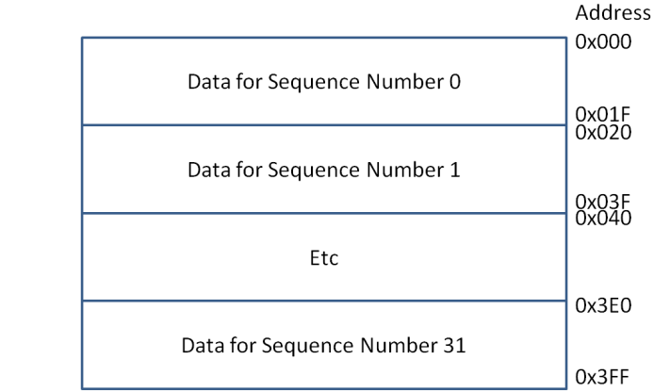
Figure 5: Sequence ROM Layout
The outputs in Figure 2 starting with “SS” or “IS”, of which there are 8, are such that only 0 or 1 of those outputs may be low at any one time.
- This information will be stored in 3 bits of a ROM word to indicate which of the 8 bits should be low, plus a 4th bit which will be used to indicate if any of the outputs should be low.
  - These outputs will be generated by a 3:8 decoder that is enabled by the 4th bit.
The outputs in Figure 2 starting with “SD” or “ID” (excluding ID_ACL), of which there are 8 are such that only 0 or 1 of those outputs may be low at any one time.
- This information will be stored in 3 bits of a ROM word to indicate which of the 8 bits should be low, plus a 4th bit which will be used to indicate if any of the outputs should be low.
  - These outputs will be generated by a 3:8 decoder that is enabled by the 4th bit.
The outputs in Figure 2 that go to the ADDR_SEL bus, of which there are 5, are such that only one of these outputs may be low at any one time.
- This information will be stored in 3 bits of a ROM word to indicate which, if any, of the 5 bits should be low. A pattern of 0 0 0 in the 3 bits will indicate that none of these outputs should be low.
  - These outputs will be generated by a 3:8 decoder that is permanently enabled.
The remaining outputs (INC_PC, SEQ_END and ID_ACL) will each be stored in one bit of a ROM word.
So the total number of bits required in a ROM word is 14.
This should be sufficient information for producing a schematic diagram for this block without needing any further level 2 design.

RAM Address Control
The function of this block is to put the required RAM address on the ABUS output.
This block contains a 16 bit latch:
- This latch is used to store a 16 bit address value from the DBUS input.
- The data bus value is stored in this latch by the control signal ID_ACL (Internal Destination Address Control Latch).
- The rules for this are defined in ref 2 section “Reading from the Data Bus”.
The values that this block may output on ABUS are:
- Ra#: The address of Ra in RAM (0..15)
- Rb#: The address of Rb in RAM (0..15)
- OPCODE: The address from the 2nd word of a 2 word instruction
- The value stored in the latch described above.
The signals that comprise ADDR_SEL determine which one of the above (or none) are put on ABUS. There must be a 16 bit (note 1) tri-state buffer for each of the above 4 items that is enabled by the corresponding ADDR_SEL signal.
Note 1: For Ra# and Rb#, which are only 4 bits, they could be implemented with a 4 bit tri-state buffer, and another shared 12 bit tri-state buffer whose inputs are hard wired to low.
This should be sufficient information for producing a schematic diagram for this block without needing any further level 2 design

Temp 16 Bit Latch1
The function of this block is to:
- Store the value from the data bus when this latch is selected to read from the data bus.
  - The rules for this are defined in ref 2 section “Reading from the Data Bus”
- Output the stored value when this latch is selected to write to the data bus.
  - The rules for this are defined in ref 2 section “Writing to the Data Bus”
This should be sufficient information for producing a schematic diagram for this block without needing any further level 2 design

Temp 16 Bit Latch2
This will be identical to Temp 16 Bit Latch1.
The only difference in its implementation, cf. Latch1, is that it will use ID_TMP2 and IS_TMP2 rather than using ID_TMP1 and IS_TEMP1.

16 Bit Tristate Buffer
The function of this block is to write 0x0001 onto the data bus when IS_0x1 is low.
The 0x0001 input is 16 bits, with bits 15 to 1 set to 0, and with bit 0 set to 1.
This should be sufficient information for producing a schematic diagram for this block without needing any further level 2 design.

L2 Design for Sequence Control
This section contains the level 2 design for the part of Figure 2 shown in Figure 6.
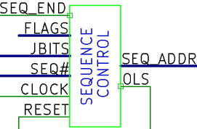
Figure 6: Sequence Control part of Figure 2
The requirements for this block are defined in 3.4.
The L2 block diagram for Sequence Control is shown in Figure 7.
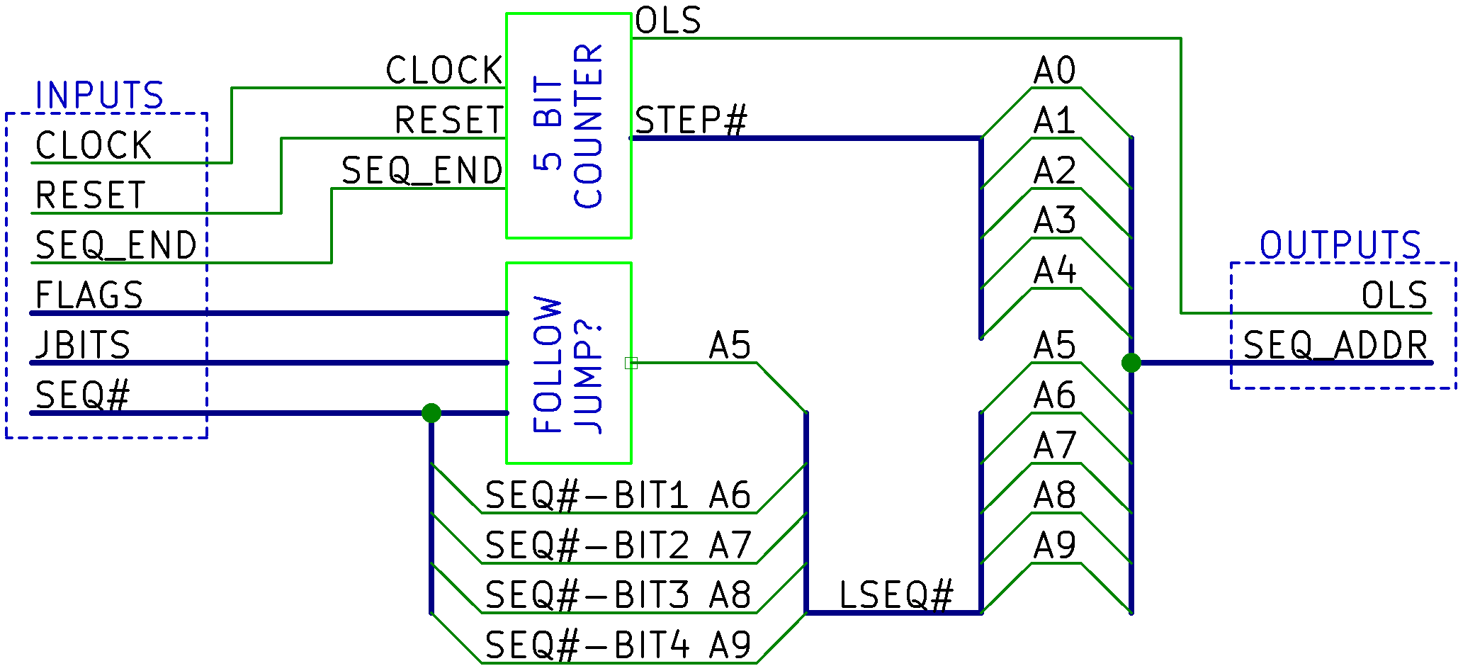
Figure 7: Sequence Control L2 Block Diagram
The following sub sections, one per block shown in Figure 7, define the function of each block.

5 Bit Counter
The function of this block is to:
- Provide the lower 5 bits of the address to the sequence ROM in SEQ_ADDR.
- Provide the OLS signal which causes the first word of each opcode to be latched.
The timing requirements for this block when RESET is high are shown in Figure 8.
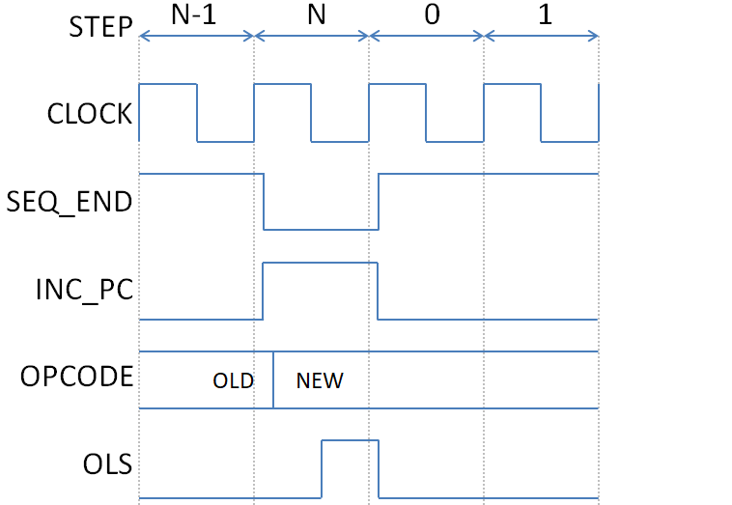
Figure 8: Timing requirements for 5 bit counter when RESET is high
Notes about Figure 8:
- STEP is as shown in ref 3. It is the count output from the 5 bit counter.
  - The figure shows the last two steps (N-1 and N) of the previous sequence and
  - The first two steps (0 and 1) of the new sequence.
- SEQ_END is produced by one of the sequence ROM outputs (see 3.5)
  - The 5 bit counter must be reset to 0 when SEQ_END is low and there is a rising edge on CLOCK.
  - When SEQ_END is high a rising edge on CLOCK must increment the counter.
- INC_PC is not used by the IS.
  - It is shown in this figure because it is what causes OPCODE to change from the previous (OLD) opcode to the NEW opcode.
  - Most sequences increment the PC on the last step of the sequence, but some (Followed jump, RET and CALL) set it to the new value earlier in the sequence. Worst case, for new opcode being available, is when it’s done on the last step, which is what is shown in this figure.
- OPCODE is the output from the Code ROM (not the sequence ROM)
- OLS is the signal that latches the new opcode into the IS opcode latch (see 3.1).
  - OLS = SEQ_END AND !CLOCK
The timing requirements for this block when RESET is low are shown in Figure 9.
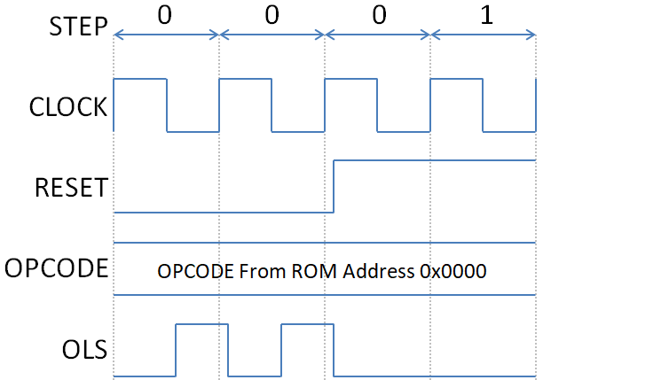
Figure 9: Timing requirements for 5 bit counter when RESET is low
Notes about Figure 9:
- STEP is as shown in ref 3. It is the count output from the 5 bit counter.
  - When RESET is low the count is reset to 0 and kept at 0.
- RESET is the “power up reset” as defined in 3.3.
- OPCODE is the output from the Code ROM (not the sequence ROM).
- OLS is the signal that latches the new opcode into the IS opcode latch (see 3.1).
  - OLS = RESET AND !CLOCK
  - The rising edge of OLS causes the new opcode to be stored in the IS opcode latch
  - The fact that there will be multiple OLS pulses is not a problem.
Combining the Boolean equations for OLS:
- Figure 8 OLS = SEQ_END AND !CLOCK
- Figure 9 OLS = RESET AND !CLOCK
Combined equation OLS = (SEQ_END OR RESET) AND !CLOCK

Follow Jump?
See ref 3 and look at “SEQ NUM” 0 and 1 for background information.
The function of this block is to decide whether sequence 0 is required (jump followed) or sequence 1 is required (jump not followed)
Inputs:
- FLAGS from ALU (see “FLAGS bus” section in ref 2)
- JBITS from opcode (see Figure 4)
- SEQ# from opcode (see Figure 3)
The Boolean equation for A5 output is:
(SEQ# == all 0’s) AND ((JBITS Flags Mask AND JBITS Flags Value) == (JBITS Flags MASK AND FLAGS))
- SEQ# == all 0’s :
  - Can be done with a 5 input NOR gate to give a one bit output that’s high if all 5 bits are 0 (call it Result A)
- JBITS Flags Mask AND JBITS Flags Value :
  - Can be done with 5 x 2 input AND gates to give a 5 bit result (call it Result B)
- JBITS Flags MASK AND FLAGS :
  - Can be done with 5 x 2 input AND gates to give a 5 bit result (call it Result C)
- (JBITS Flags Mask AND JBITS Flags Value) == (JBITS Flags MASK AND FLAGS)
  - Reduces to (Result B == Result C)
  - Can be done with 5 x 2 input XNOR gates to give a 5 bit result where each XNOR gate output = 1 if the two inputs are equal (call it Result D)
  - Result D can be converted to a single bit with a 5 input AND gate (call it result E)
- So A5 = !(Result A AND Result E) which can be done with a 2 input NAND gate.
The above solution isn’t the only way to produce A5, it’s just an example. It may be more convenient to use different combinations of gates to achieve the same result.
This should be sufficient information for producing a schematic diagram for this block without needing any further level 3 design.

References
- AVR Instruction Set Manual
- CpuDesign.docx
- L1IsSequences.xlsx
- CPU opcodes.xlsx

